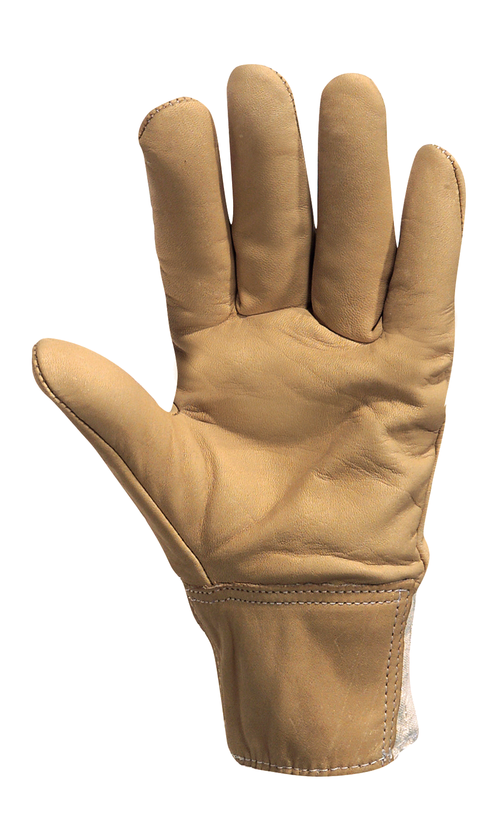
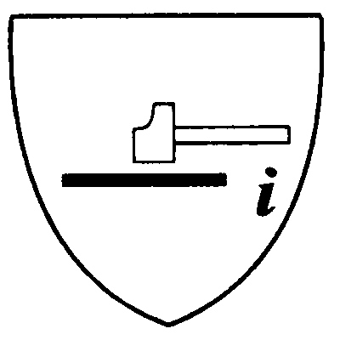

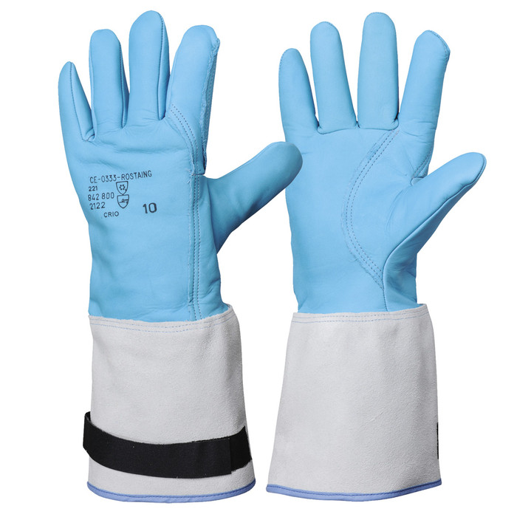
Technical Sheet

Wet handling

USE :
WORK SITES, LINEMEN,
WET ENVIRONMENT, CABLING, MAINTENANCE.

PRODUCT ADVANTAGES

BREATHABLE LEATHER, WATER REPELLENT, ARTERY GUARD,
CUT RESISTANCE

PERFORMANCES

PROTECTION LEVELS

Model meets the requirements of European standards:

EN 420 General Requirements
EN 388 Protection Against Mechanical Hazards
MECHANICAL HAZARDS
Abrasion resistance: 2 out of 4 levels
Blade cut resistance: 3 out of 4 levels
Tear resistance: 4 out of 4 levels
Puncture resistance: 2 out of 4 levels
wetcut/01
HEAT AND FIRE
Fire resistance: 2 out of 4 levels
Contact heat: 3 out of 5 levels
Convective heat: 4 out of 4 levels
Radiant heat: 2 out of 4 levels
Small splashes of molten metal: 2 out of 4 levels
Large splashes of molten metal: 2 out of 4 levels
DESCRIPTION & MAINTENANCE

COLD HANDLING
CRYOGENIC HANDLING

USE
PRODUCT ADVANTAGES
WATERPROOF
HYDROPHILIC, MICROPOROUS MEMBRANE
SELF-GRIPPING RIBBON FOR TIGHTENING CUFF
PERFORMANCE
PROTECTION LEVEL
Model meets the requirements of the European Standards:

EN 420 1994 General Requirements
EN 388 1994 Protection Against Mechanical
Hazards
EN 511 Protection Against the Cold

Homologation delivered by the notified
Organization IFTH/LYON
No 0072/011/162/05/97/0139

Model certified suitable for submersion in liquid nitrogen (method IFTH MR 019)

MECHANICAL HAZARDS

2 Abrasion resistance out of four levels
1 Blade cut resistance out of five levels
2 Tear resistance out of four levels
2 Puncture resistance out of four levels

American cut five-finger glove with full index finger
Glove + thumb/index finger reinforcement in 1 mm thick cowhide, fire repellent
Glove lined with woollen fleece and hydrophilic, microporous insert
Total length 40 cm including a 15 cm split cow hide cuff.
Tightening band on cuff. Polyamide thread seams
Packaging: package of 5 pairs, box of 10 pairs

Available sizes: 8. 9. 10. 11

DESCRIPTION & MAINTENANCE

CRIO

ROSTAING SA Tél : 04 74 46 07 15 Fax : 04 74 61 34 43
17, avenue Charles de Gaulle Tél : 0033(0)4 74 46 34 55 Fax : 0033 (0) 4 74 61 34 43
01800 VILLIEU LOYES MOLLON Mail : contact@rostaing.fr Web : www.rostaing.com

THERMAL HAZARDS

2 Convective cold out of four levels
2 Contact cold out of four levels
1 Waterproofness out of one level

